OBTAINING DIGITAL PHOTO (EXIF Metadata) INFORMATION
Digital image information on items like format, file size, date taken, etc. (EXIF Metadata) is available on all phone/computer devices. HOWEVER, if you are having difficulty locating this information you can use one of many free websites to access the EXIF data. Here is an example:
STEP 1) CLICK HERE to access the free Jimpl.com on-line EXIF data viewer. You do not have to download the app to use.
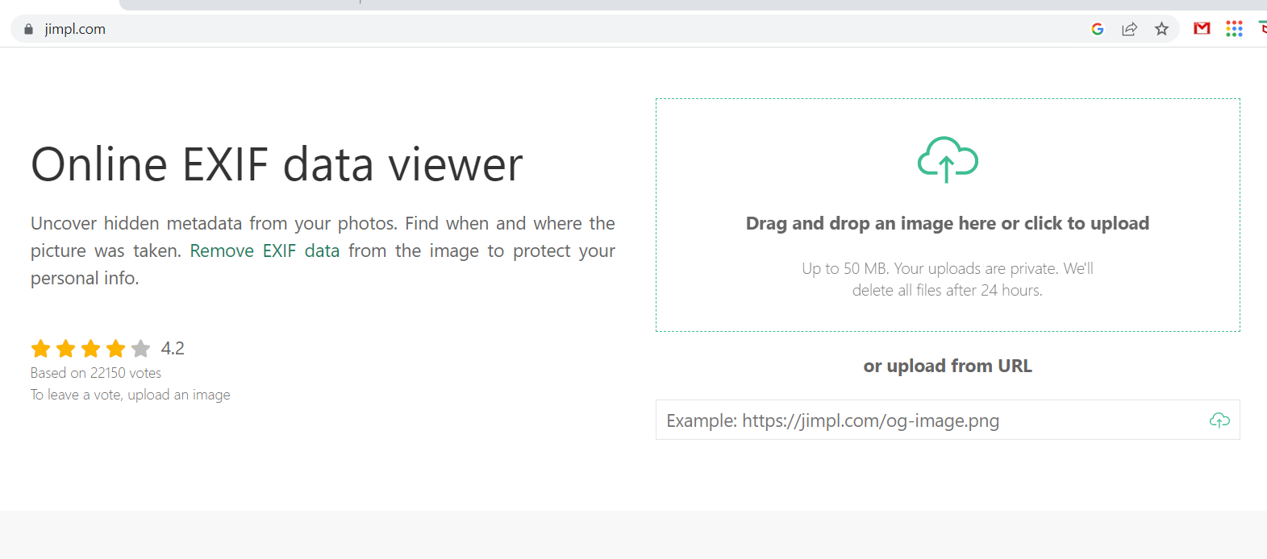

STEP 2) Click on the Drag and Drop Window and navigate to the desired image. Then click OPEN to upload your image. NOTE: You may also use the image URL for Metadata access.
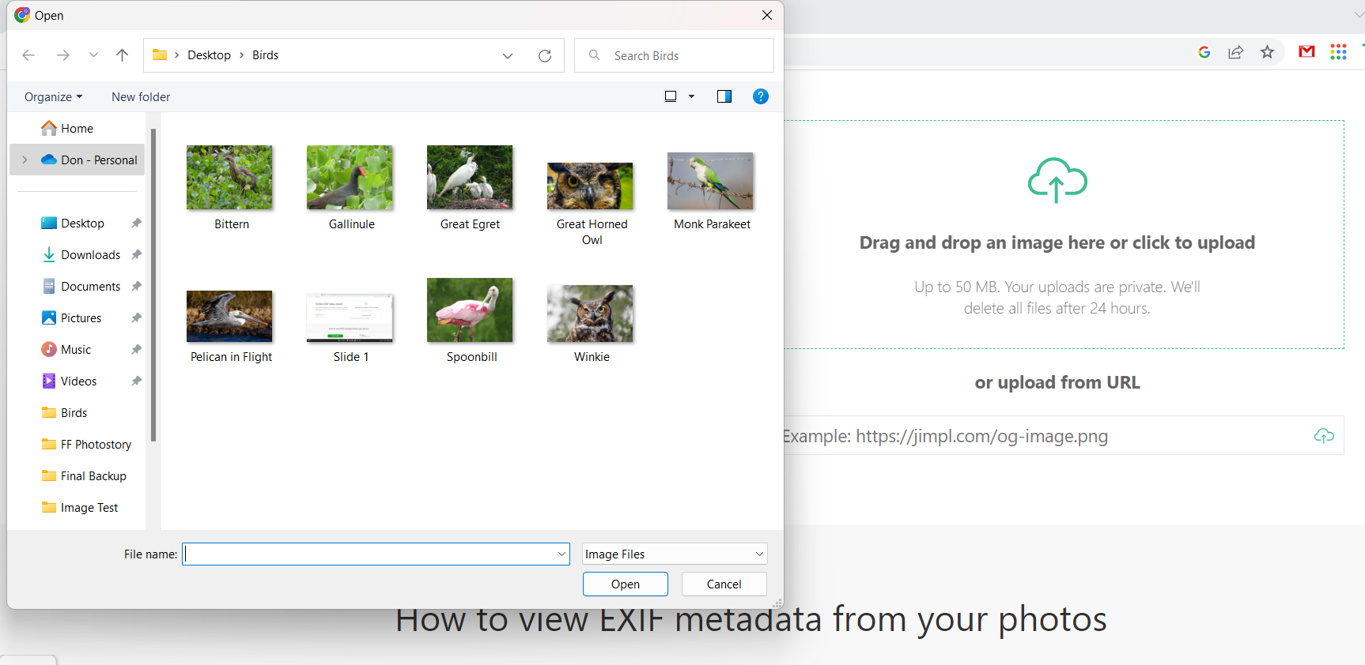
STEP 3) The UPLOADED image will appear in the viewer, accompanied by the EXIF Metadata on the right.
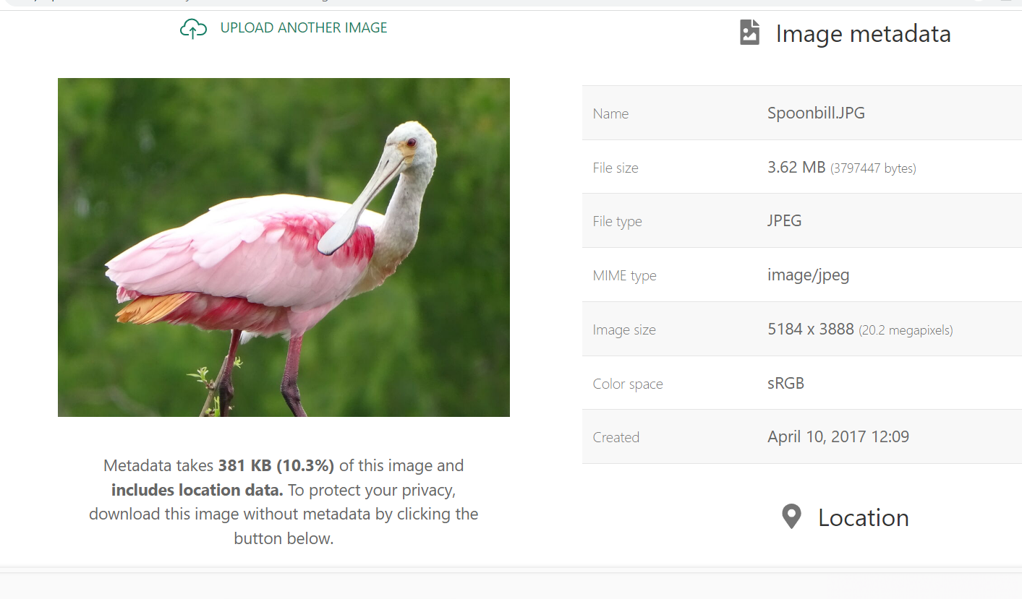

STEP 4) Review the information to determine if the image meets specifications for the Featherfest Photo Contest (e.g. Date taken, JPG format, less than 6 mb in size and a minimum of 1800 pixels on the longest side). Non-compliant photos will be eliminated from the competition.
STEP 5) If the image is within the above specifications, return to the Featherfest Photo Contest Entry Form and submit your photo.

